Introducing Audit

Adapted from:
Making Medical Audit Effective, Joint Centre for Education in Medicine
Available from JCEM, 33 Millman St, London WC1N 3EJ Tel 0171 831 6222 Price £12.50
Very Easy to Read and Invaluable Guide

Definition
White Paper: Working for Patients
The Systematic, critical analysis of the quality of medical care, including the procedures used for diagnosis and treatment, the use of resources, and the resulting outcome and quality of life for the patient

A useful working description is:
A systematic quantified comparison against explicit standards of current medical practice in order to improve the quality of care to patients

Facts
• Audit is a Process of Learning
• Audit is about improving the overall standard of patient care rather than trying to witch hunt bad people
• Audit should be non threatening to those being evaluated

The Audit Cycle

Types of Audit - SPA
- Structure - concerned with the amount and type of resources eg equipment
- Process - relates to amount and types of activities of medical care, ix or procedures
- Outcome - the most relevant indicator of clinical care (ie intervention should results in an outcome)

Methods of Audit
- Criteria based audit
- Adverse occurrence screening
- Critical incident Review
- Patient Survey
- Peer Review

Setting Up An Audit

• Choosing a problem
Needs to perceived and agreed by all involved
Should be a solvable one
• Setting objectives
Should be clearly defined, realistic, patient orientated and achievable

• Setting criteria
Should be measurable
The boundaries of the measurement need to be defined by a clear ‘yardstick’
eg on the first or second visit
within 3 days of .....

• Defining standards
Should be realistic
should reflect current professional opinion (national or unit basis)
Should be set as early as possible in the audit cycle (preferably before practice is evaluated)

• Selecting outcome indicators
Should be valid, specific, efficient and measurable
• Time strategies
Decide whether retrospective or prospective audit
Retrospective tends to be the more practical one

• Gather data

• Interpret the data and follow audit cycle through

• Close the loop
Decide when to repeat the audit in order to complete the cycle

Remember, always keep audit simple!

What to do when the Audit is over

Hold an Audit Meeting
Discuss the audit findings
Audit Meetings are useful because they enable us to
• learn from the standard setting process
• identify needs of the whole groups as judged by the audit results
• identify needs of the individual
• assess needs ie knowledge vs skills vs attitudes
• agree on an education plan jointly
ie a self determined learning programme (problem based learning)

Championing
Always appoint a person who has an interest in the particular area of change to ensure the the changes do happen eg a nurse to ‘champion’ the changes in warfarin protocol

Always remember that you are obliged to Confidentiality Rules to Protect Patients and Staff

Identifying Learning Needs
Usually fall into one or more of the following groups
Lack of knowledge (ignorance of facts)
Lack of Skills (poor performance of practical steps)
Poor Attitude (inappropriate application of knowledge or skills)

Different Ways of Learning
• Reading Plan
• Tutorials
• Counselling
• Interactive video/computing package
• Discussion of video of person in action
• Writing a revised protocol
• Demonstration
• Shadowing an ‘expert’ to learn new approaches to clinical problems
• Secondment to a ‘centre of excellence’ to learn practical skills

Is Audit the same as Research
Answer : No

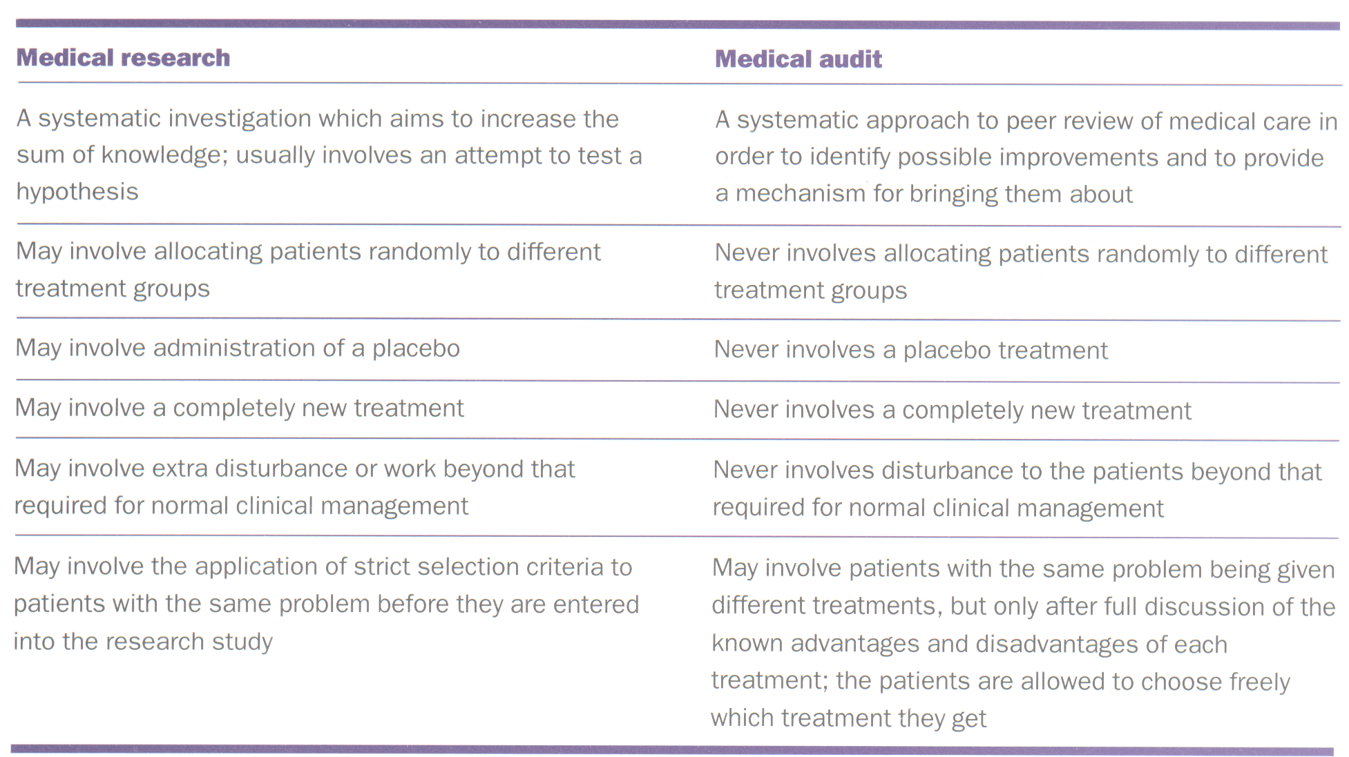

In Summary:

Audit is about addressing problems in a non-threatening fashion

